Name: ________________________________________________ Class Period: ____________ Test Date: ____________

Biology Test Study Guide Key All answers will be scored on a scantron.
Cell Structure and Function

Introduction to Cells

Use the microscope image below to answer the questions to the right.

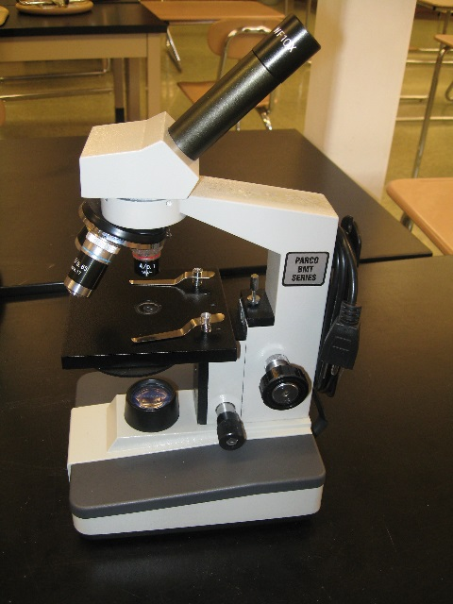
1. What is the name of this type of microscope?
Compound Light Microscope

2. What is this type of microscope used for?
This microscope looks through/into transparent objects like cells.

3. How do you find total magnification using this microscope?
Multiply the eyepiece by the objective lens. Example: Eyepiece 10x and objective lens 20x then total magnification is 200x.
4. What was unusual about the letter “e” that we looked at using this microscope?
Everything is upside down/backwards in this microscope.

5. List the three parts of the Cell Theory.
- All living things are made of cells
- One cell has all structure and function of a living organism
- Cells come from pre-existing cells
6. What 4 cell parts can be found in ALL cells AND describe the function of each cell part.

Cell membrane: outer layer of cell; controls what goes in and out of the cell
DNA: genetic material; all genetic information about the cell
Cytoplasm: liquid environment in which all cell parts are found
Ribosomes: make proteins

7. List three differences between a prokaryotic cell and a eukaryotic cell?
- Prokaryotic cells do not have a nucleus protecting the DNA; eukaryotic cells do have a nucleus
- Prokaryotic cells do not have organelles; eukaryotic cells do have organelles
- Prokaryotic cells are much smaller; eukaryotic cells are larger

8. When given a picture of a cell, how will you determine if it is a prokaryotic or eukaryotic cell?

Look for a nucleus. It will be a dense round region which is protecting the DNA. You could also look for all of the different specialized organelles. Prokaryotic cells do not have these but eukaryotic cells do.

Inside the Eukaryotic Cell

9. Identify the function of each cell part and label that cell part in the images below. Note: During the test you will be asked to apply your knowledge of these cell parts. It will not be as simple as matching term to definition! Students have flash cards for all parts.

Nucleus: Protects DNA; the control center of eukaryotic cells.

Cell Membrane: outer layer of all cells; controls materials coming in and out of the cell

Endoplasmic Reticulum: transportation system of cell; materials (usually proteins) travel along the ER

Golgi Apparatus: packages and labels materials (usually proteins) before they are shipped out of the cell

Mitochondrion: turns food energy into energy for the cell; powerhouse

Chloroplast: plant cells only; makes food for the cell using sunlight, water, carbon dioxide (photosynthesis)

Vacuole: stores food, water, and/or waste for the cell; large in plant cells; smaller in animal cells

Lysosome (will not be in image below): breaks down and recycles waste

Cell Wall: outer protective layer for structure and support for plant cells and some bacteria
chloroplast
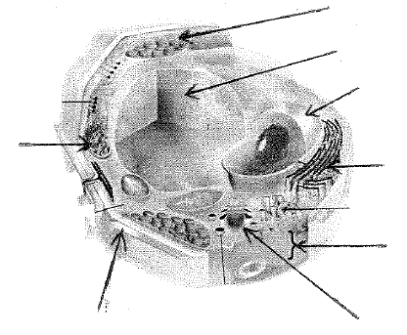
cell wall
c.membranee
Gogi
ER
nucleus
vacuole
mitochondria
10. Is this cell prokaryotic or eukaryotic? How do you know?
Eukaryotic. It has a nucleus and organelles.

11. Is this cell an animal or plant cell? How do you know?
Plant cell. It has a chloroplast, cell wall, and large vacuole.

12. What two parts are found in plant cells but not animals cells?
Chloroplast, cell wall
From Cell to Organism

13. Identify an organism that is unicellular. Identify an organism that is multicellular. Which is more common on earth?
Unicellular (bacteria); Multicellular (human); Unicellular more common but because we cannot see them we don’t think about them as much.
14. List the levels of cellular organization in a multicellular organism from smallest to largest.
Cell → Tissue → Organ → Organ System

