Name: ________________________________________________ Class Period: ____________ Test Date: ____________

Biology Test Study Guide All answers will be scored on a scantron.
Cell Structure and Function

Introduction to Cells

Use the microscope image below to answer the questions to the right.

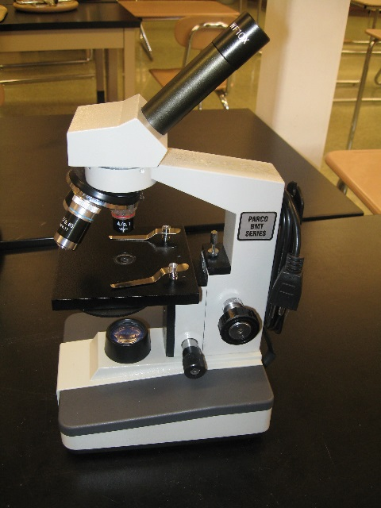
1. What is the name of this type of microscope?

2. What is this type of microscope used for?

3. How do you find total magnification using this microscope?

4. What was unusual about the letter “e” that we looked at using this microscope?

5. List the three parts of the Cell Theory.

6. What 4 cell parts can be found in ALL cells AND describe the function of each cell part.

7. List three differences between a prokaryotic cell and a eukaryotic cell?

8. When given a picture of a cell, how will you determine if it is a prokaryotic or eukaryotic cell?

Inside the Eukaryotic Cell

9. Identify the function of each cell part and label that cell part in the images below. Note: During the test you will be asked to apply your knowledge of these cell parts. It will not be as simple as matching term to definition!

Nucleus

Cell Membrane

Endoplasmic Reticulum

Golgi Apparatus

Mitochondrion

Chloroplast

Vacuole

Lysosome (will not be in image below)

Cell Wall
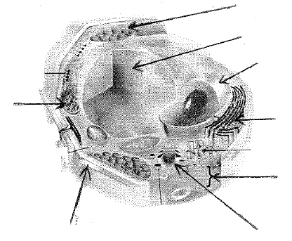
10. Is this cell prokaryotic or eukaryotic? How do you know?

11. Is this cell an animal or plant cell? How do you know?

12. What two parts are found in plant cells but not animals cells?
From Cell to Organism

13. Identify an organism that is unicellular. Identify an organism that is multicellular. Which is more common on earth?

14. List the levels of cellular organization in a multicellular organism from smallest to largest.

