Name: ____________________________
Class Period: _______________________

Review Quarter 1

- A community containing both cottontail and jackrabbits would be called homogeneous or heterogeneous?
_____________________ How did you know? ____________________________________________________

- What process uses light to make chemical energy? _____________________

- Write the chemical equation for this process below.

- Bart believes that mice exposed to microwaves will become extra strong. To test his hypothesis, Bart designed and experiment. Below are the procedures for this experiment.

Microwave Effects on Mouse Strength:

1. Place 10 mice of various sizes in the microwave for 10 seconds.
2. Have each mouse push a 100 gram block of wood for one minute.
3. Measure the distance the block has moved and record the distance in the data table.
4. Obtain 10 identical non-microwaved hamsters.
5. Have each hamster push a 500 gram block of wood for two minutes.
6. Measure the distance the block has moved and record the distance in the data table.

- We know that this is not an ethical experiment. List 3 problems with his experimental procedure.

- What is the control group? How did you know?

- What is the experimental group? How did you know?

- What is the independent variable? How did you know?

- What is the dependent variable? How did you know?

- What could be done to improve this experiment?

- Biologists introduced Pheasants into
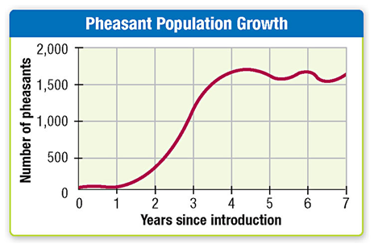
Washington State in the 1930s. Their population
growth is shown in the graph to the right. What is
the carrying capacity of the Pheasants in this area?

________________________________

How did you know?

__________________________________________
___________________________________________
___________________________________________

- The nonliving parts of the environment are called _______________________.

- The living parts of the environment are called ______________________.

- Complete the following chart with how the organisms react to the symbiotic relationship and give an example of this relationship. Use the terms benefits, harmed, unaffected.

Type of Relationship | Organism A Organism B | Example
Parasitism
Mutualism
Commensalism

- Draw a food web with the following terms for organisms: grass, oak tree, mouse, snake, owl, coyote, deer, grasshopper, bacteria.

- Circle the producers, underline the consumers and draw a box around the decomposers.
- Put a star next to the herbivores, an “X” next to the carnivores, and a smiley face next to the omnivores.
- What is the difference between exponential and logistical growth? You may draw graphs showing this if you wish.

- Draw the carbon cycle with the following labels: photosynthesis, cellular respiration, decomposition, combustion. Hint: Start by drawing the ground, a living tree, a dead tree, a factory, and at least one animal.

- What organisms take nitrogen from the atmosphere and put into a form plants can use, (Nitrogen fixation)? ________________________
- Find Carbon on a periodic table. What is it’s atomic number? _________
- What is Carbons’ atomic mass? _________
- Draw a carbon atom. Label the protons, neutrons, and electrons.

- What is the atomic symbol for Carbon? _____
- How many valence electrons does carbon have? _____
- What is the chemical formula for one water molecule? _______________________

21.
Specific Examples
 | How do you use this? | What foods give us this? | What picture can represent the shape?
Carbohydrates
Lipids
Proteins

Photosynthesis & Cellular Respiration Practice

Process | What goes in? | What comes out? | Where does this happen?
Photosynthesis | Words:  Chemical Formulas: | Words:  Chemical Formulas:
Cellular Respiration | Words:  Chemical Formulas: | Words:  Chemical Formulas:
Fermentation | Words:  Chemical Formulas: | Words:  Chemical Formulas:

