Name: _________________________________________________ Class Period: _____________ Quiz Date: __________

Chapter 8: Cells In Their Environment Use your Chapter 8 Notes and Osmosis Lab!
Quiz Study Guide

Crossword: Use the clues below to complete the crossword puzzle that follows.

Across
1. a type of diffusion in which molecules pass directly through the phospholipid membrane
5. the diffusion of WATER through the cell membrane
7. the movement of ANY molecule from high concentration to low concentration
8. the outer layer of a cell that is made of lipids, protects the cell, and controls what goes in and out of the cell
9. the type of lipid that makes up the cell membrane
10. maintaining an internal balance; staying the same

Down
2. when molecules diffuse through the cell membrane without energy needed
3. a type of diffusion in which transport proteins are needed for help
4. the type of protein that allows larger molecules to pass in and out of the cell
6. when molecules are evenly spread out

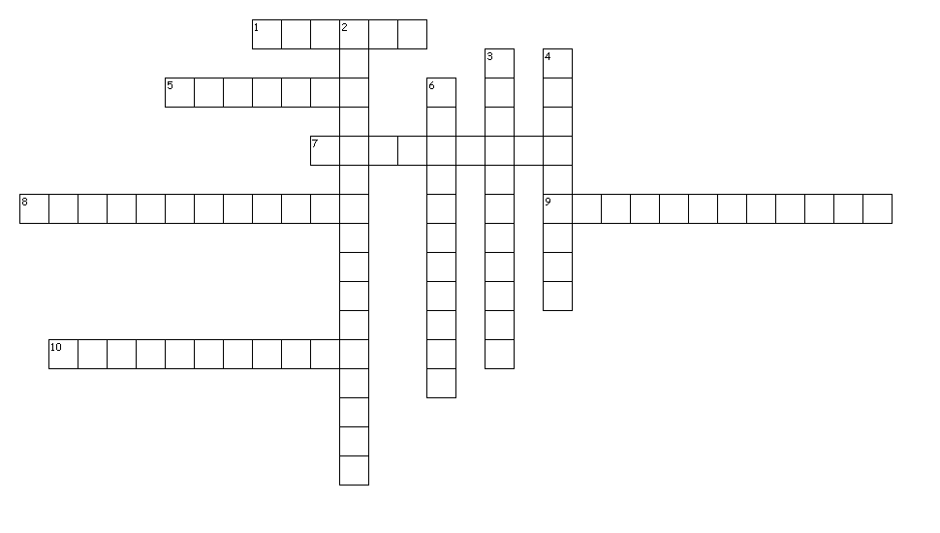
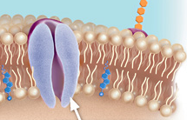
11. Label one phospholipid and one
transport protein in the image to the right.

Use the images below to
a. Draw an arrow showing the direction that water will move
b. Identify the solution as hypertonic, hypotonic, or isotonic

12. 13. 14.
10% Solute
90% Water
10% Solute
90% Water
50% Solute
50% Water

30% Solute
70% Water
10% Solute
90% Water
10% Solute
90% Water

Solution:
Solution:
Solution:

15. 16. 17.
Solution:
Solution:
Solution:
10% Solute
90% Water
40% Solute
60% Water
10% Solute
90% Water
20% Solute
80% Water
20% Solute
80% Water
20% Solute
80% Water

18. What is active transport? _________________________________________________________________

19. What new cell part is used to move very large molecules through the membrane? ___________________

20. What type of protein is used to communicate with other cells? ___________________________________

The test will be worth a total of 52 points. There will be 5 questions (10 pts) from previous units. You will need to know the difference between an independent and dependent variable, the word roots homeo and hetero, what cell parts are responsible for making proteins and making energy, how to determine if a cell is prokaryotic, and the differences between an animal and plant cell. Feel free to make any notes below.

