Name: _________________________________________________ Date: _________________ Class Period: _________
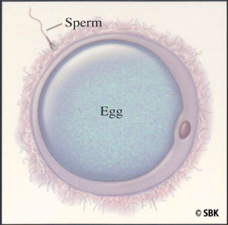

Chapter 11: Meiosis and Sexual Reproduction
Section 1: Reproduction
Asexual Reproduction
1. Reproduction is the process of producing ________________________.
2. Asexual Reproduction, a ______________ parent passes a complete copy of its ___________________ information to each of its ___________________.
3. An individual formed by asexual reproduction is genetically ___________________ to its parent.
4. An example of an organism that reproduces asexually is a(n) _______________________.
Sexual Reproduction
1. In sexual reproduction, ______ parents give genetic material to produce offspring that are genetically _______________________ from their parents.
2. Reproductive cells are called _________________.
3. When two gametes fuse together, the resulting cell is called a _________________ which has a combination of genetic material from both parents. This process is called ____________________________.
4. What is the advantage of sexual reproduction of a species? ______________________________________
____________________________________________________________________________________________________________________________________________________________________________________
Chromosome Number
1. Each chromosome has thousands of _________ that play an important role in determining how an organism ________________ and ___________________.
2. When fertilization of humans occurs, the zygote will contain ________ chromosomes. Therefore, the gametes (reproductive cells) must have _______ chromosomes each.
3. Regular body cells with two complete sets of chromosomes (one set from each biological parent) is called ______________ cell.
4. Gametes (reproductive cells) which have half the normal number of chromosomes are called ____________ cells.
5. Chromosomes that are similar in size, shape and kind of genes are called ______________________ ________________________________.

6. Label the Homologous Chromosomes Below.

7. Autosomes are chromosomes with genes that ____ _____ determine the _______ of an individual.
8. Sex Chromosomes have genes that determine the _______ of an individual.
9. Males have one ____ and one _____ chromosome, while females have two ______ chromosomes.
10. Use the karyotype (picture of chromosomes below) to label homologous chromosomes, autosomes, and sex chromosomes.

Male Karyotype Female Karyotype
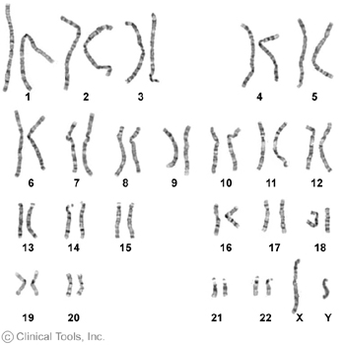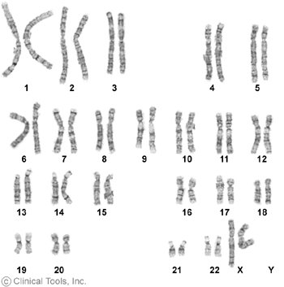

Section 2: Meiosis
Stages of Meiosis
1. ____________ is a form of cell division that produces daughter cells with _________ the number of chromosomes as the parent cell; making gametes (reproductive cells),
2. Before meiosis, the chromosomes of the original cell are ____________. This occurs during interphase (DNA Replication).
3. During Meiosis I, _________________ ___________________ are separated and in Meiosis II the sister chromatids are separated.
Meiosis I (Notes not directly from book!)
1. During Meiosis I, homologous chromosomes pair up and crossing over occurs. During crossing over, chromatids exchange ________________ ___________________. This occurs during Prophase I of Meiosis I. Crossing over will create genetically ______________ daughter cells.

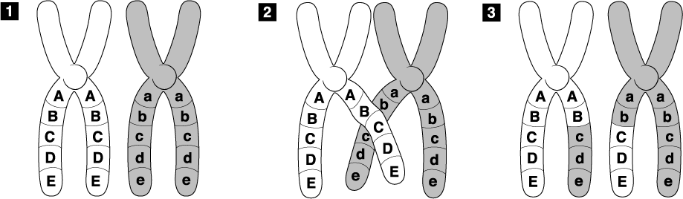

2. During Meiosis II, each daughter cell will be divided again by the sister chromatids being pulled apart.
3. The end result of Meiosis is ______ genetically __________________ cells with ________ the number of chromosomes. Human meiosis results in cells with _______ chromosomes.

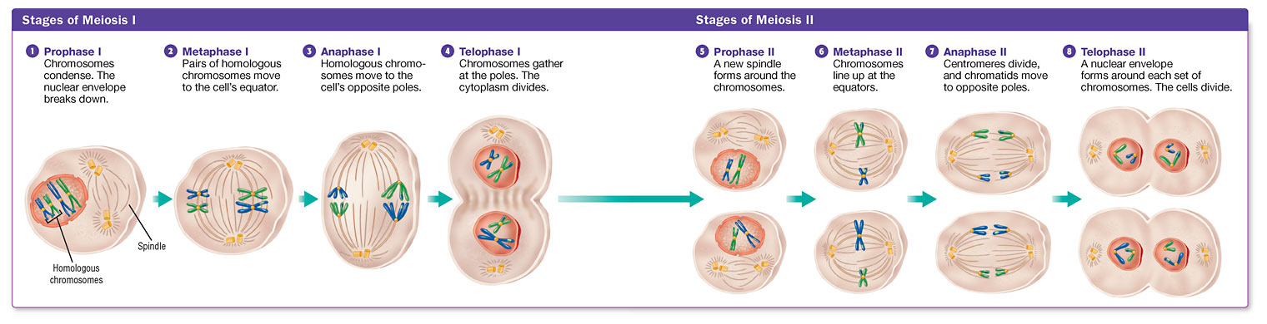

Comparing Mitosis and Meiosis
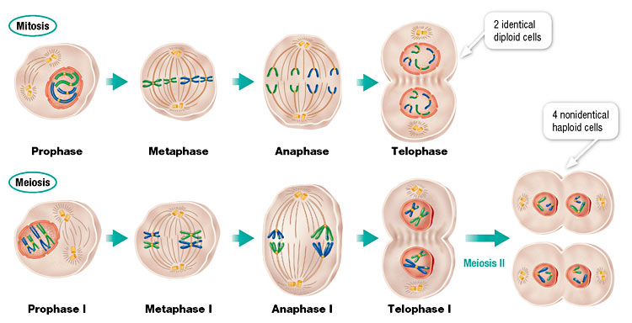

Use the figure above and book page 252 to compare the two processes.
 | Mitosis | Meiosis
Goal of Process
Type of Cells Made
Number of Cells Made
Genetic Identity of New Cells
Compare Metaphase

