Name: _________________________________________________ Date: _________________ Class Period: _________
Textbook Website: http://my.hrw.com
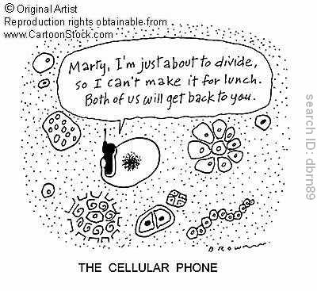
Username: etong30
Password: biology

Chapter 10: Cell Growth and Division
Section 1: Cell Reproduction
Why Cells Reproduce: pg 223
1. How many cells are produced by humans in one day? _______________________
2. The process of making exact copies of cells to replace old ones is called _____________________________.
3. A body grows by producing more ___________ rather than the existing cells getting larger.
4. There are two main reasons why large cells are inefficient. The first is that as a cell gets larger, substances must travel ________________ to reach where they are needed. The second is the demands placed on the cell’s DNA. DNA instructions cannot be copied quickly enough (DNA→mRNA) to make the _____________ the cell needs to support itself.
5. During cell division, each new cell called a “______________” cell is smaller than the original cell and gets an entire copy of the cell’s ___________.
Chromosomes: pg 224-225
1. A cell’s activity is directed by its _________.
2. A gene is a segment of ________ that codes for _______ and _______________.
3. Packages of DNA are called _________________.
4. A Prokaryotic cell has a single ____________ molecule of DNA.
5. A human cell contains ______ separate, linear DNA molecules that are packaged into 46 _______________.
6. DNA wound around proteins is called _______________.
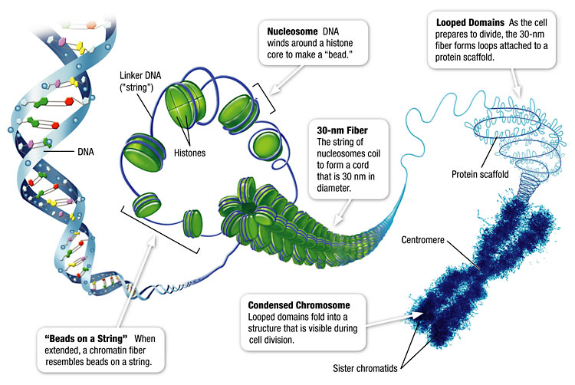
7. During most of a cell’s life its chromosomes are uncoiled, but as the cell prepares to divide, the chromosomes ____________________ even further. This ensures that the DNA molecules don’t get ________________ _____ during cell division.
8. In the figure below, label the parts of the chromosome. Chromosome, chromatid, centromere, sister chromatids, genes.
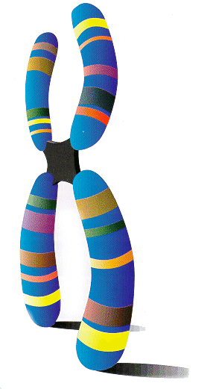

Preparing for Cell Division: pg 226
1. All new cells are produced by the _________________________________________________________.
2. All newly formed cells require ________, so before a cell divides, a copy of DNA is made for each ___________________________.
3. What is the name of the process in which identical copies of DNA are made? (not in book) ________________________________________.
4. In prokaryotic cell division the DNA is copied then the cell membrane pinches in half creating two genetically __________________ cells.
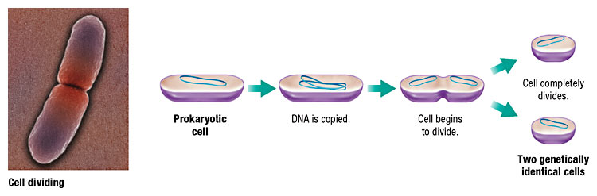
5. In eukaryotic cell division each daughter cell must contain enough of each ________________ to carry out its functions. The __________ within the nucleus must also be copied, sorted, and ____________________.
Section 2: Mitosis
Eukaryotic Cell Cycle: pg 228-229
1. The cell cycle is the _________________ sequence of cellular __________ and _______________ during the life of a cell.
2. The life of a eukaryotic cell goes through phases of __________, _________________________, _________________________________________, and __________________ of the nucleus and cytoplasm.
Interphase
3. For each phase of Interphase, describe what is taking place.
G1 (first gap phase): ____________________________________________________________________________________ ____________________________________________________________________________________
S (synthesis phase): ____________________________________________________________________________________ ____________________________________________________________________________________
G2 (second gap phase): ____________________________________________________________________________________ ____________________________________________________________________________________
Cell Division
4. The process of dividing the nucleus into two daughter nuclei is called ________________.
5. The process of separating the organelles and the cytoplasm is called _________________.
Stages of Mitosis: pg 230-231
1. Mitosis is a continuous process that can be observed in four stages: ___________________, ____________________, ____________________, and ____________________.
2. Before we begin with the phases of Mitosis, define the terms below.
Spindle: _____________________________________________________________________________
Centrioles: ___________________________________________________________________________
3. For each phase of Mitosis, describe what is taking place.
Prophase: ____________________________________________________________________________________ ____________________________________________________________________________________
Metaphase: ____________________________________________________________________________________ ____________________________________________________________________________________
Anaphase: ____________________________________________________________________________________ ____________________________________________________________________________________
Telophase: ____________________________________________________________________________________ ____________________________________________________________________________________
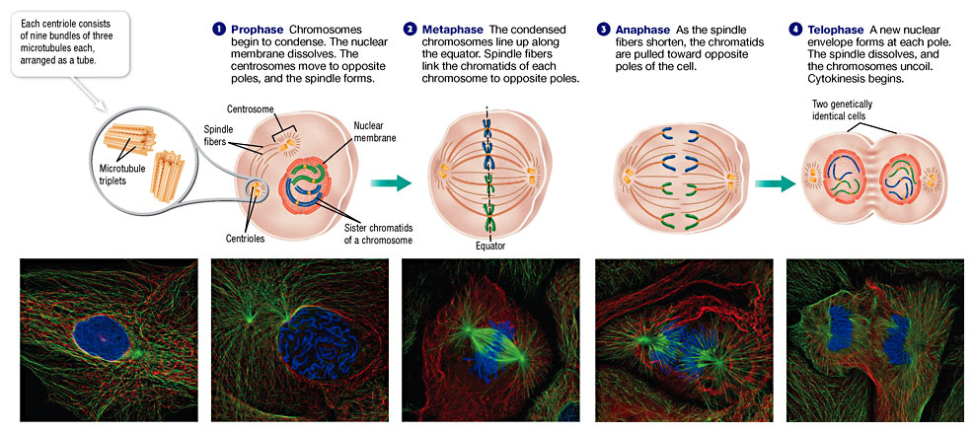
Cytokinesis
1. During cytokinesis, the _______________________ grows into the center of the cell and ___________ into two _______________ cells of equal size. Each daughter cell has about half of the parent’s ____________ and ______________. The end result is ___________ genetically ____________________ cells in place of the original cell.
2. ____________ cells perform cytokinesis by pinching from the outside in.
3. ____________ cells perform cytokinesis by forming a cell plate and dividing from the inside out.
4. After cytokinesis, each daughter cell enters the ______ stage of _________________.
Section 3: Regulation
Controls
1. Cell growth and division depend on __________ ______________ and other __________________ signals.
Checkpoints
1. Feedback ___________ at key checkpoints in the cell cycle can ___________ or _____________ the next phase of the cell cycle.
Cancer
1. Cancer is a group of severe and sometimes fatal diseases that are caused by _________________________________________.
2. Damage to cell’s _______ can cause the cell to respond improperly or to _______ responding. The defective cell _______ and produces more _________ cells that eventually can form masses called _________.
3. What is one way that cancer can be prevented? ________________________________________________

