Prokaryotic cell | A cell that does not have a nucleus; bacteria  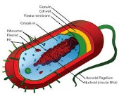
Eukaryotic Cell | A cell that has a nucleus and organelles; plant and animal  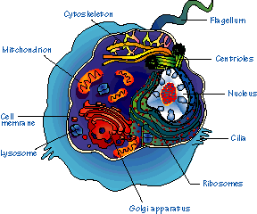
Nucleus
Cytoplasm
Cell Membrane
Ribosomes
Mitochondria
Chloroplast
Endoplasmic Reticulum (ER)
Golgi apparatus
Lysosome
Vacuole
Cell Wall
Cilia
Flagella

