Name: _____________Key___________________________________ Class Period: __________ Test Date: ___________

Biology Test Study Guide
Chapter 10 Cell Growth and Division
Chapter 11 Meiosis and Sexual Reproduction

Cell and Cell Membrane Review

1. What is the job of the nucleus of a cell? Control the cell parts; contains DNA

2. What is the job of a cell membrane and what is it made of? Protect the cell, control what goes in and out, made of phospholipids.
3. What is osmosis? Movement of WATER across the cell membrane

4. Why does a cell in a hypotonic solution get bigger? Water concentration was higher outside the cell than inside the cell causing water to move in to the cell.

5. List the three parts of the Cell Theory. All living things are made of cells. All cells arise from existing cells. Cells are the basic units of structure and function in organsims.
Chapter 10: Cell Growth and Division

1. How is s chromosome different than a sister chromatid? Chromosomes are packages of DNA. Sister chromatids are identical copies of chromosomes made during the S-phase of Interphase.
2. How is a parent cell different than a daughter cell? In cell growth and division, the cell that you start with is the parent cell. Cells you finish with are called daughter cells.
3. Label one chromosome, sister chromatids, and centromere in the diagram below.
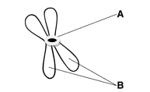 4. When does this chromosome copy? S-phase of Interphase
A: centromere
B: sister chromatids
half of B: chromosome
5. Complete the diagram below by labeling the phases of the cell cycle.
Word Bank for Diagram

a. Prophase (4)
b. Anaphase (6)
c. Cytokinesis (8)
d. Metaphase (5)
e. G1 (1)
f. G2 (3)
g. S (2)
h. Telophase (7)
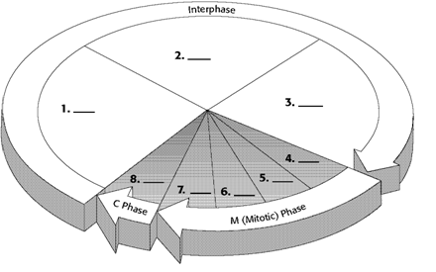
Chapter 11: Meiosis & Sexual Reproduction

1. What is the difference between asexual and sexual reproduction? Asexual is one parent cell making genetically identical offspring. Sexual is two parent cells making genetically different offspring.
2. What are the advantages of sexual reproduction? Sexual reproduction creates genetic diversity in a species. This diversity makes a population more able to adapt to environmental change.
3. What is the difference between a diploid cell and a haploid cell? Diploid cells contain two complete sets of chromosomes (one set from each parent; humans 46 chromosomes). Haploid cells contain one set of chromosomes (half the diploid number; humans 23; reproductive cells)
4. What is a gamete? a reproductive cell; example: sperm/eggs/pollen

5. What is a zygote? a cell created when two gametes unite in fertilization; example: sperm + egg = human zygote

6. What is crossing over? an exchange of genetic information between homologous chromosomes; occurs during prophase I of meiosis I; creates genetically different daughter cells to be used in sexual reproduction

7. You will have to explain in detail how biological siblings get such different characteristics. This will be an extended response question. To get all points you must demonstrate a clear understanding of the goal of meiosis, the process of meiosis, use of appropriate vocabulary terms, and refer to a specific family as evidence. You can practice this on a separate piece of paper or type it. I would be happy to look this over before the test date.
Example: Bart and Lisa Simpson have the same biological parents even though they are very different. When Homer produced sperm cells through meiosis, crossing over during prophase I caused each sperm cell to have a different genetic identity. When Marge produced egg cells through meiosis, crossing over during prophase I caused each egg cell to have a different genetic identity. The sperm and egg that combined to make Bart was genetically different than the sperm and egg that combined to make Lisa.

Compare and Contrast Mitosis and Meiosis

Fill in blank or circle the correct answer.

 | Mitosis | Meiosis
Goal of Process | To make genetically identical cells. | To make genetically different cells with half the chromosome number.
Type of Cells Made | Diploid or Haploid | Diploid or Haploid
Number of Cells Made each Time | 2 or 4 | 2 or 4
Example of a Cell that uses this Process | Muscle Cell or Sperm Cell | Muscle Cell or Sperm Cell
What lines up during metaphse? | Sister Chromatids  or Homologous Chromosomes | (Metaphse I)  Sister Chromatids  or Homologous Chromosomes

Lastly…you will be given some images of cells and will need to identify the phase that cell is in. Please use all review resources on the class website www.colemanbio.weebly.com/cells (bottom of the page).

