Name: ___________________________________________________ Class Period: __________ Test Date: ___________

Biology Test Study Guide
Chapter 10 Cell Growth and Division
Chapter 11 Meiosis and Sexual Reproduction

Cell and Cell Membrane Review

1. What is the job of the nucleus of a cell?

2. What is the job of a cell membrane and what is it made of?

3. What is osmosis?

4. Why does a cell in a hypotonic solution get bigger?

5. List the three parts of the Cell Theory.

Chapter 10: Cell Growth and Division

1. How is s chromosome different than a sister chromatid?

2. How is a parent cell different than a daughter cell?

3. Label one chromosome, sister chromatids, and centromere in the diagram below.
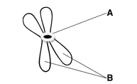 4. When does this chromosome copy? _____________________

5. Complete the diagram below by labeling the phases of the cell cycle.
Word Bank for Diagram

a. Prophase
b. Anaphase
c. Cytokinesis
d. Metaphase
e. G1
f. G2
g. S
h. Telophase
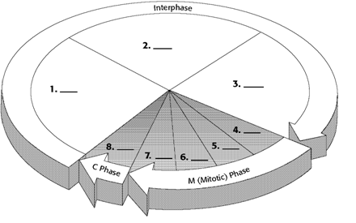
Chapter 11: Meiosis & Sexual Reproduction

1. What is the difference between asexual and sexual reproduction?

2. What are the advantages of sexual reproduction?

3. What is the difference between a diploid cell and a haploid cell?

4. What is a gamete?

5. What is a zygote?

6. What is crossing over?

7. You will have to explain in detail how biological siblings get such different characteristics. This will be an extended response question. To get all points you must demonstrate a clear understanding of the goal of meiosis, the process of meiosis, use of appropriate vocabulary terms, and refer to a specific family as evidence. You can practice this on a separate piece of paper or type it. I would be happy to look this over before the test date.

Compare and Contrast Mitosis and Meiosis

Fill in blank or circle the correct answer.
 | Mitosis | Meiosis
Goal of Process | To make genetically ______________ cells. | To make genetically _____________ cells with half the chromosome number.
Type of Cells Made | Diploid or Haploid | Diploid or Haploid
Number of Cells Made each Time | 2 or 4 | 2 or 4
Example of a Cell that uses this Process | Muscle Cell or Sperm Cell | Muscle Cell or Sperm Cell
What lines up during metaphse? | Sister Chromatids  or Homologous Chromosomes | (Metaphse I)  Sister Chromatids  or Homologous Chromosomes

Lastly…you will be given some images of cells and will need to identify the phase that cell is in. Please use all review resources on the class website www.colemanbio.weebly.com/cells (bottom of the page).

