Name: ___________________________________________ Date: _________ Class Period: ______________

**Beyond Mendelian Genetics**

**Practice Problems**

**Science Skills**

1. Number the items below from smallest (1) to largest (6)

____ DNA ____ Chromosome ____ Nucleotide ____ Nucleus ____ Cell ____ Atom

2. Match the karyotype description with the correct image.

a. Normal Female b. Down Syndrome Male c. Normal Male

____ [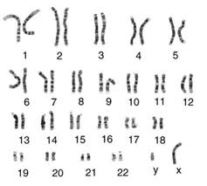](http://www.google.com/imgres?hl=en&biw=1366&bih=610&tbm=isch&tbnid=C5DwOKPmlj3PcM:&imgrefurl=http://www.biotechnologyonline.gov.au/popups/img_karyotype.html&docid=XG6ZJK8w_w-UdM&imgurl=http://www.biotechnologyonline.gov.au/images/contentpages/karyotype.jpg&w=560&h=502&ei=owAkUdjiA6aZyQG4tYGYCw&zoom=1&ved=1t:3588,i:157&iact=rc&dur=4724&sig=111329155553848472732&page=1&tbnh=182&tbnw=215&start=0&ndsp=12&tx=147&ty=118) ____ 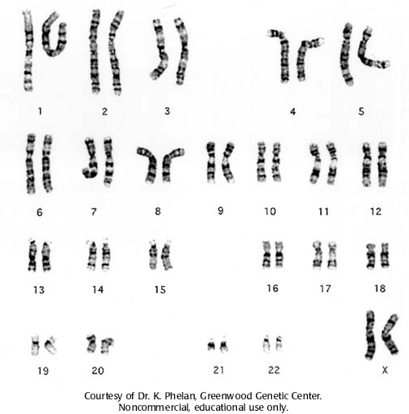 ____ 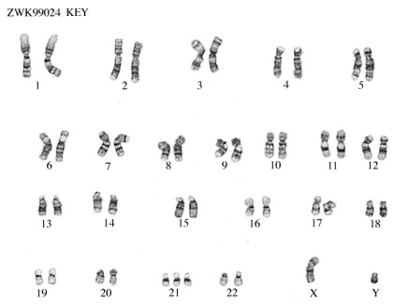

3. Match the pattern of inheritance with its description or example.

a. Polygenic b. Incomplete c. Multiple Allele d. Codominance

____ More than two alleles exist for one gene.

____ Two phenotypes appearing at the same time in heterozygous individuals.

____ Many genes combine to produce one phenotype.

____ Heterozygous individuals display a “blended” phenotype.

____ Example: Human Blood Type (Type A, Type A, Type O)

____ Example: Human Height

____ Example: Human Hair Texture

____ Example: Erminette (Speckled) Chickens

**Completion**

4. Sex-Linked traits are found on the ____ or _____ chromosomes. Females have two ____ chromosomes and males have one _____ and one ______ chromosome. Baldness is an example of a sex-linked, X-linked recessive disorder. Circle all individuals below that are colorblind.

XBXB  XBXb XbXb XBY XbY

Create a Punnett Square for a female carrier and a bald male.

Are any sons bald? _______ Where did they get their baldness from? _______

**Science Skills**

Examine the pedigree for albinism shown below, and then answer the questions that follow. You may need to use a Punnett square to answer some of these questions. (Albinism is a genetic condition in which an individual produces no pigment in his or her skin, hair, or eyes.)

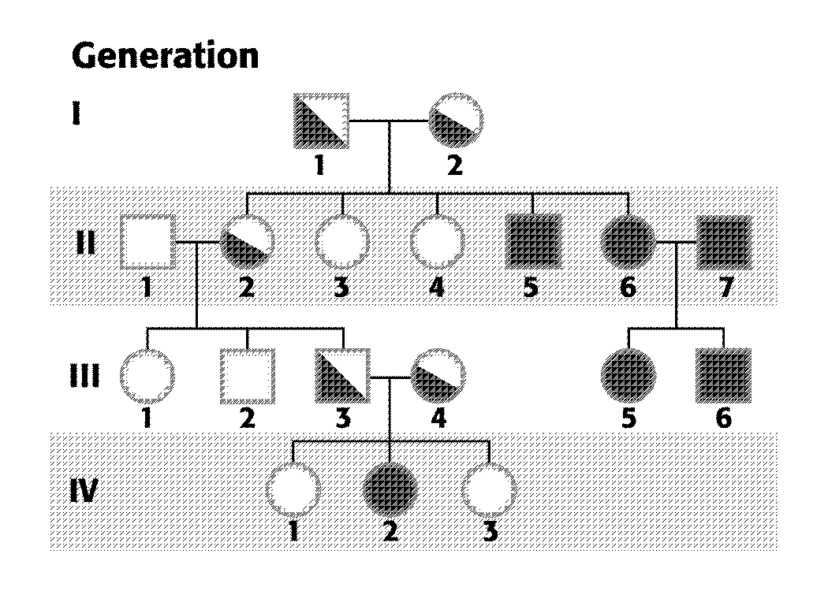

Do you think albinism is a dominant trait or a recessive trait? ______________

Explain your answer. ______________________________________________________________________________

______________________________________________________________________________

What are the genotypes for individuals with albinism? _______ Carrier? _______ No albinism? ________

Write the genotypes for each individual in the pedigree above.

How many total males are represented on this pedigree? _____

How many total females? ______

How many individuals in Generation II had albinism? ______

How many individuals in Generation III were carriers of the trait? _______

If man 3 and female 4 of Generation III have another child, what is the chance that that child will have albinism?

Draw a pedigree for the Davis family. Mr. Davis does not have albinism and is not a carrier. Mrs. Davis is a carrier. They had two boys and one girl. All were carriers.

Use the pedigree below to answer the questions that follow. You may need to use a Punnett Square for some questions. Note: Half shaded carriers are not yet shown.

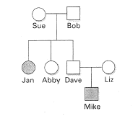

List the names of the people with the trait. __________________________________________

Is this a recessive or dominant trait? _________________________

Explain how you know. _______________________________________________________________________

__________________________________________________________________________________________

Is this disorder sex-linked? _______ Explain. ______________________________________________________________

__________________________________________________________________________________________________

Possible Genotypes. Has the trait __________ Carrier for trait __________ No trait _________

Write any possible genotype for each individual on the pedigree above.

If Mike has the trait but his parents do not. What must be the genotype for Mike’s parents? _______

Half shade all known carriers.

If Jan married a man who was heterozygous for this trait, what is the probability that any one of their children would have the trait? ____________

Draw a pedigree for the Belk family. Mrs. Belk has the trait and Mr. Belk is a carrier for the trait. They have two daughters and two sons. Both daughters are carriers, one son has the trait, and the other son is a carrier.

Interpreting Pedigrees: Read the description of the pedigree, underline name of the trait, underline if it is autosomal or sex-linked (this will determine genotypes), and write all possible genotypes beside each individual **BEFORE ANSWERING ANY QUESTIONS**!

*Earlobes*

Morphology of human earlobes is an autosomal recessive trait.

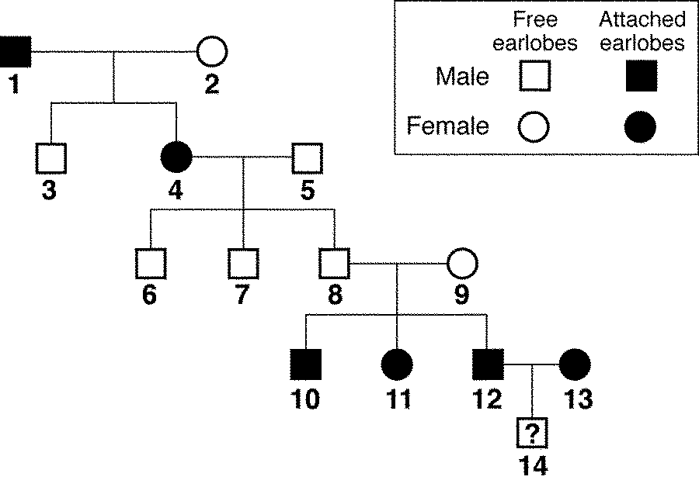

1. How many children do individuals 1 and 2 have? _________ How many children do individuals 8 and 9 have? ______

2. How many sons do individuals 8 and 9 have? _____

3. What are the probable genotypes of individuals 8 and 9? _______ Why? ____________________________________

_________________________________________________________________________________________________

4. What is the probably genotype of individual 14? ______ Phenotype? ___________________

5. What is the probable genotype of individual 2? ______ Why? _____________________________________________

*Huntington’s Disease*

Huntington’s Disease is an autosomal dominant disease of the nervous system. All known genotypes are given.



1. Shade in all individuals that are known to have Huntington’s disease.

2. What is the most probable genotype for individual D who has the disease? _______

Why? ______________________________________________________________________________________

2. If individuals C and D have another child, what is the probability of this child having Huntington’s disease? ________

*Duchene Muscular Dystrophy*



1. How did female H inherit this disorder? _______________________________________________________________

2. How did male K get the disorder if his father did not have it? ______________________________________________

3. If individuals C and D have another son, what is the chance that the son will have the disorder? __________________

Next Up…Practice Quiz with Sickle Cell and Hemophilia Pedigrees. I know it’s not easy. Keep practicing!